PIXEL SHOOTER ODYSSEY

A MINI PROJECT ON PYTHON

Created by Group P8

**GROUP MEMBERS UNIVERSITY ROLL REG NO. CLASS ROLL**

**SOUMEN MAJI**  10900223196 231090120738 200

**SAIKH RISAT**  10900223193 231090120735 203

**PRASANTA BAR** 10900223189 231090120731 204

**BIDYUT MIDYA** 10900223187 231090120729 201

**KONARK KUMAR MANDAL** 10900223188 231090120730 197

**ABHINAV KUMAR SINGH** 10900223201 231090120784 189

**RAJA JAY MONDAL** 10900223190 231090120732 202

**AYAN RAZA**  10900223186 231090120728 196

**ROHIT CHOWDHURY** 10900223192 231090120734 192

GITHUBLINK:-

https://github.com/CodingBuddyofficial/Pixel-Shooter-Odyssey

Department- Information Technology

Semester - 3rd

Year - 2nd

**OBJECTIVE**

PIXEL SHOOTER ODYSSEY is a simple yet engaging shooting game built using Python and the Pygame library. In this game, players take control of a player tasked with defending himself against waves of enemy.The gameplay is straightforward and addictive. Players navigate their itself using the WASD keys to move horizontally and vertically across the screen. The space bar is used to shoot bullets at incoming enemy.The objective of the game is to survive for as long as possible while destroying as many enemy ships as you can. As players progress, the difficulty level increases with faster enemy ships and more challenging enemy formations.

**Key Features:-**

**Simple Controls:** Players can easily move using WASD keys for movement and the space bar to shoot.

**Dynamic Enemy AI**: Enemy move in various patterns and formations, increasing the challenge as players advance.

**Power-Ups:** Occasionally, power-ups such as extra ammo or medikit advantages to the player.

**Engaging Sound Effects and Music:** Immersive audio enhances the gaming experience, with sound effects for shooting, explosions, and background music to set the tone.

Objective and key features

**SNAPSHOTS**

START-UP SCREEN:-

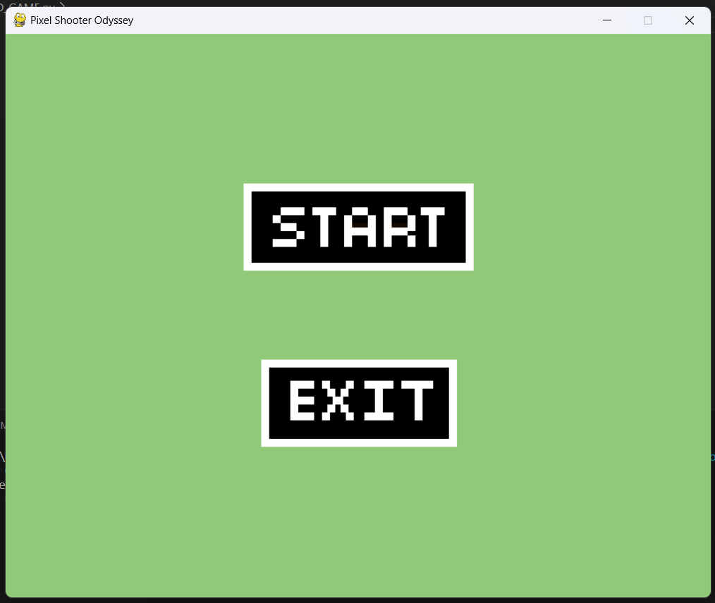

OPENING:-

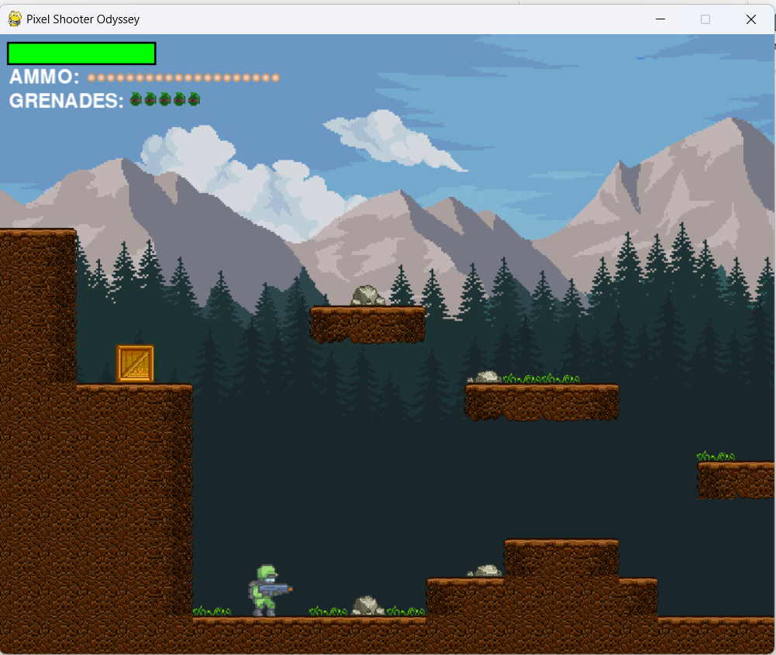

SNAPSHOTS OF GAME SCREEN

PLAYER FIRST LOOK:-



PLAYER HEALTH BAR,AMMO AND GRENADES



PLAYER JUMPING:-

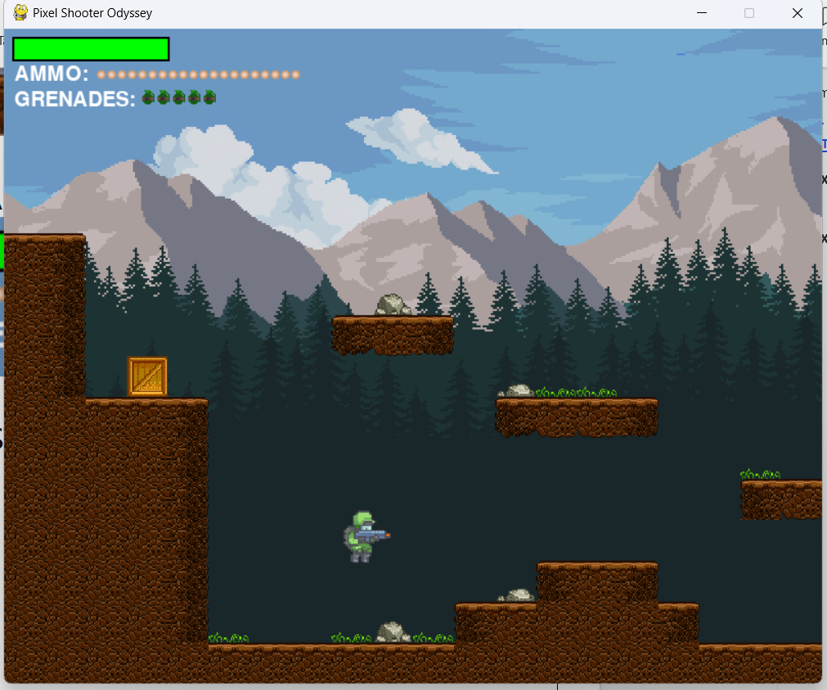

SNAPSHOTS OF GAME SCREEN

PLAYER HEALTH DROP:-

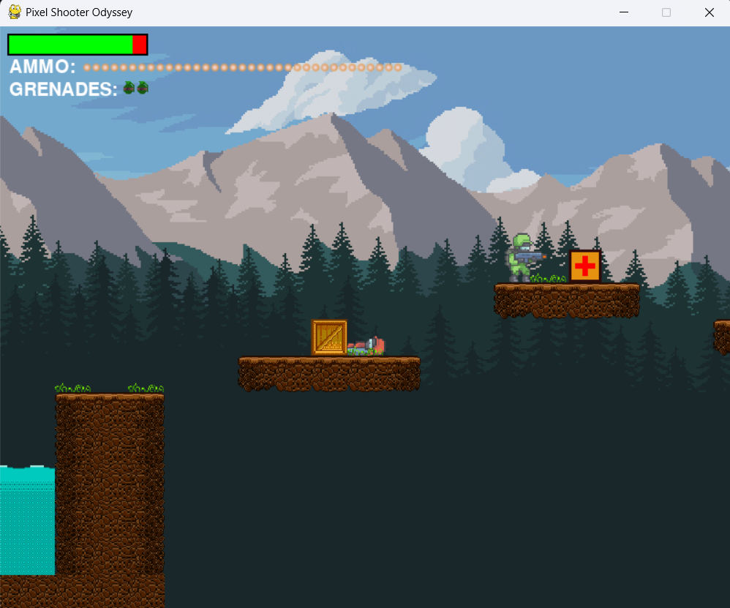

PLAYER SHOOTING:-

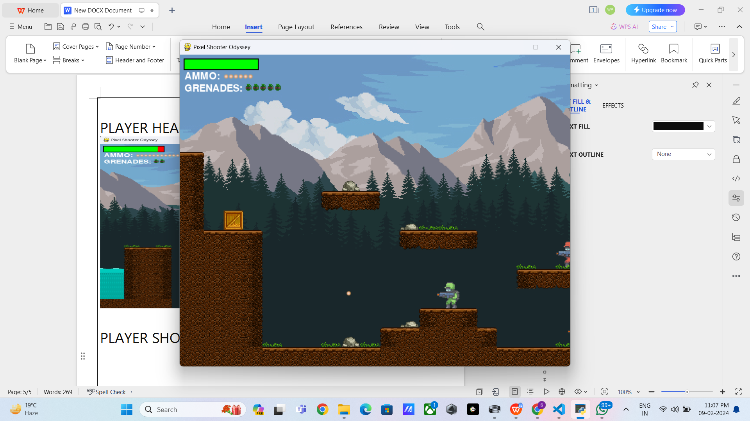

SNAPSHOTS OF GAME SCREEN

PLAYER THROWING GRENADES:-

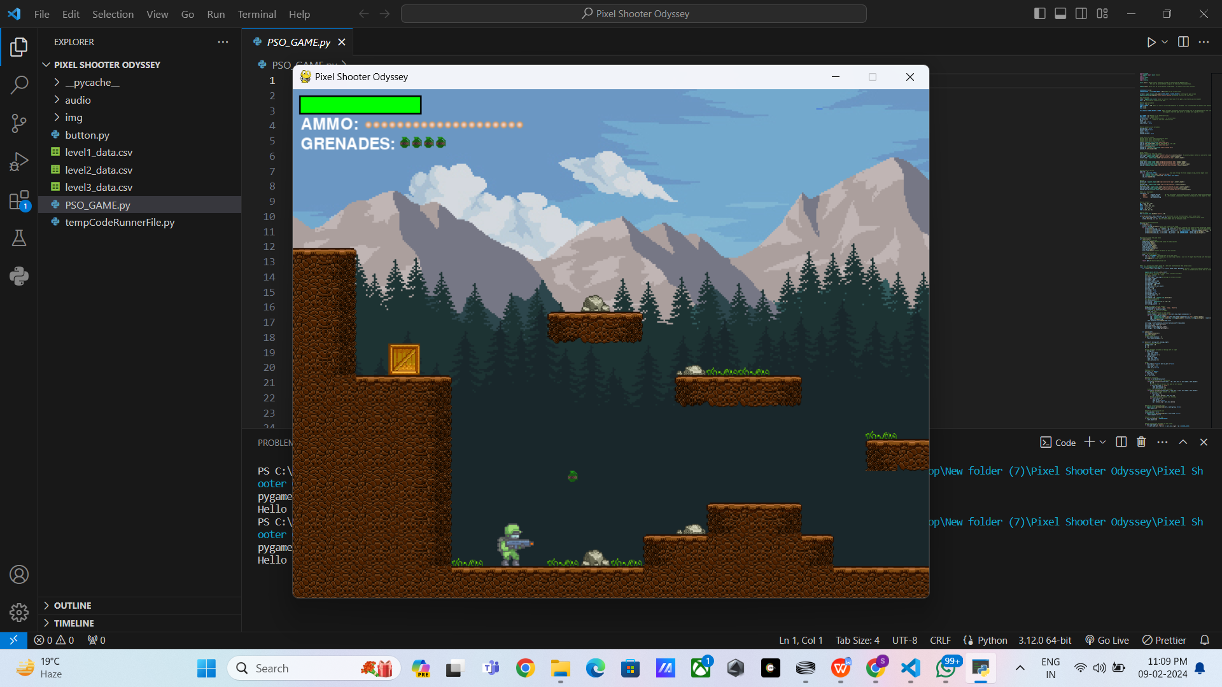

PLAYER DEAD:-

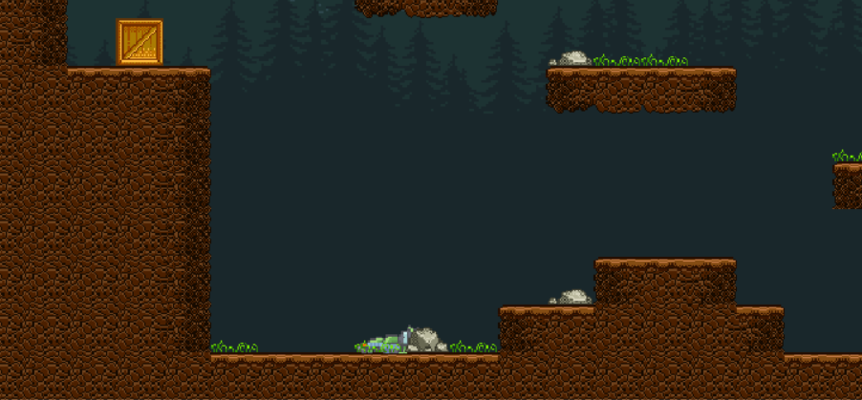

SNAPSHOTS OF GAME SCREEN

RESTART SCREEN:-

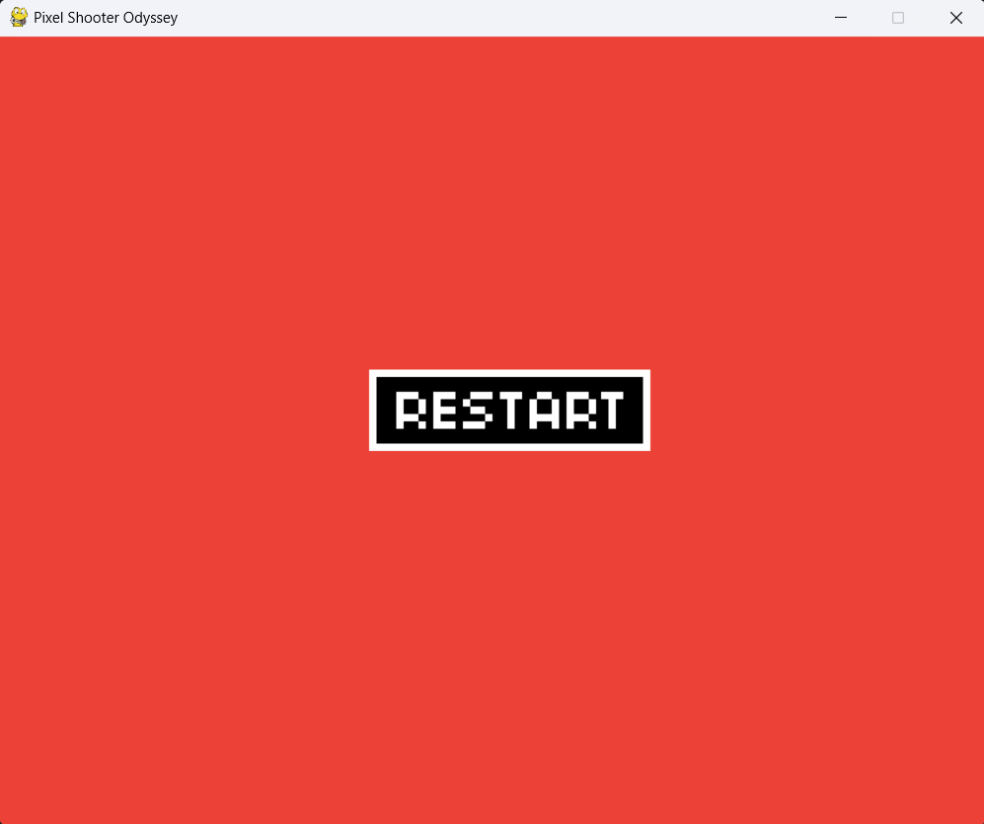

EMEMY FIRST LOOK:-

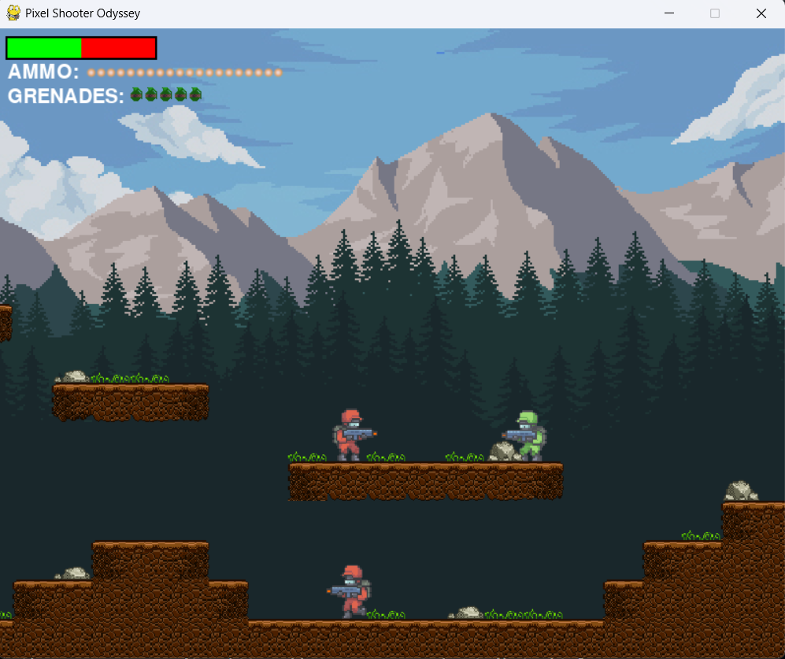

SNAPSHOTS OF GAME SCREEN

EMEMY SHOOTING:-

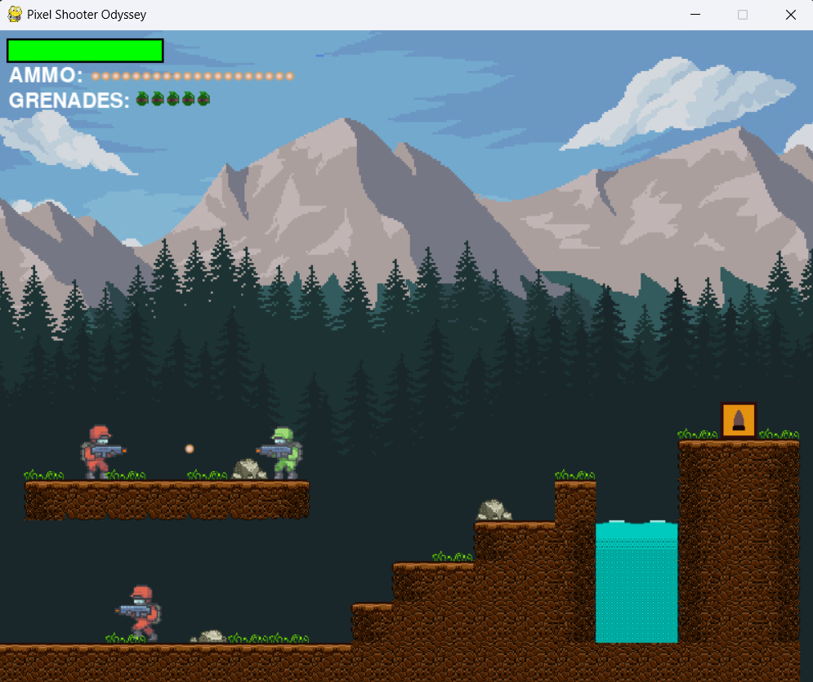

EMEMY DEAD:-

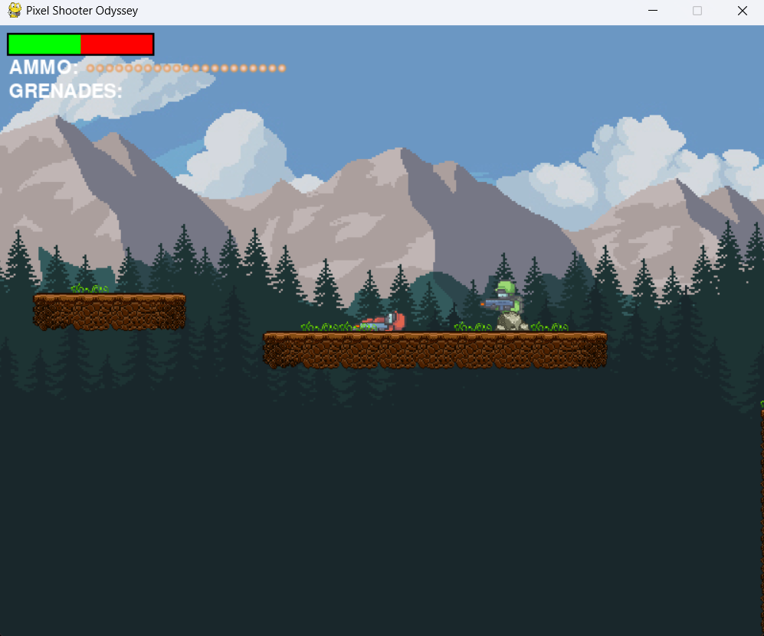

SNAPSHOTS OF GAME SCREEN

AMMO DROP:-

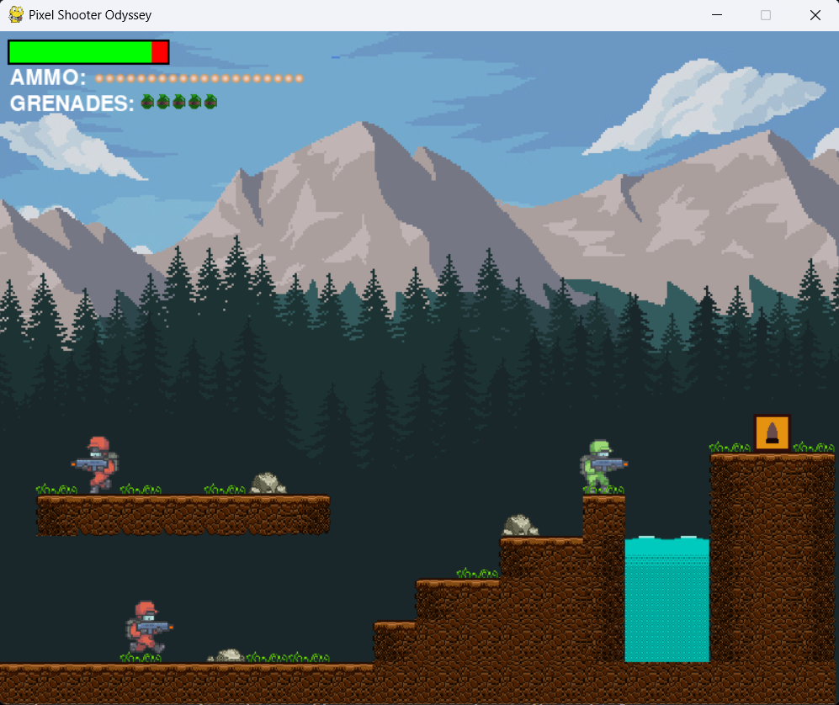

MEDIKIT:-



SNAPSHOTS OF GAME SCREEN

LEVEL PASS CHECKPOINT:-

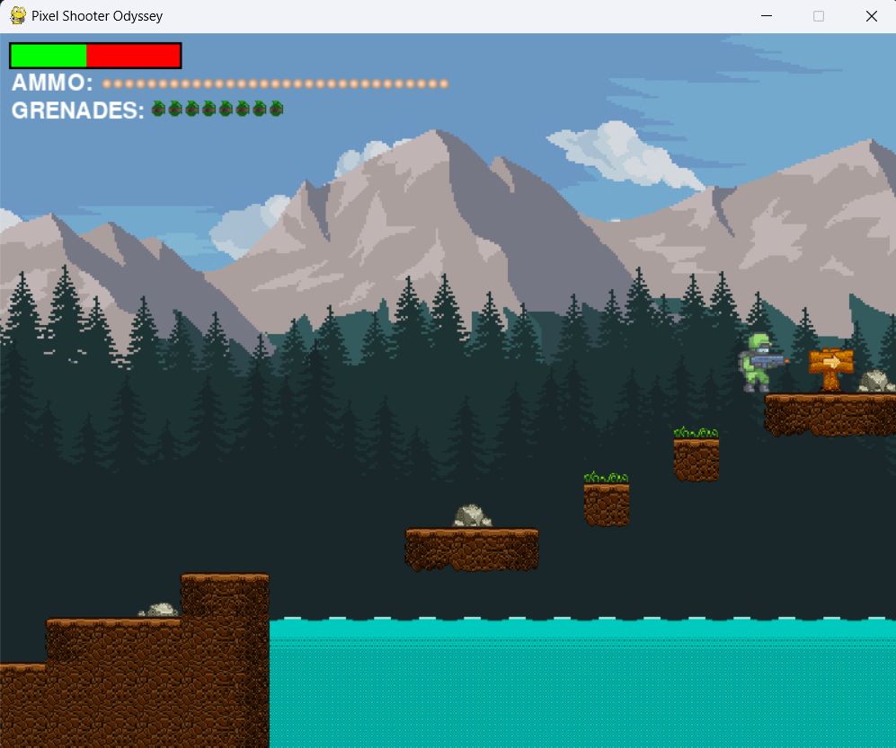

GRENADE DROP:-

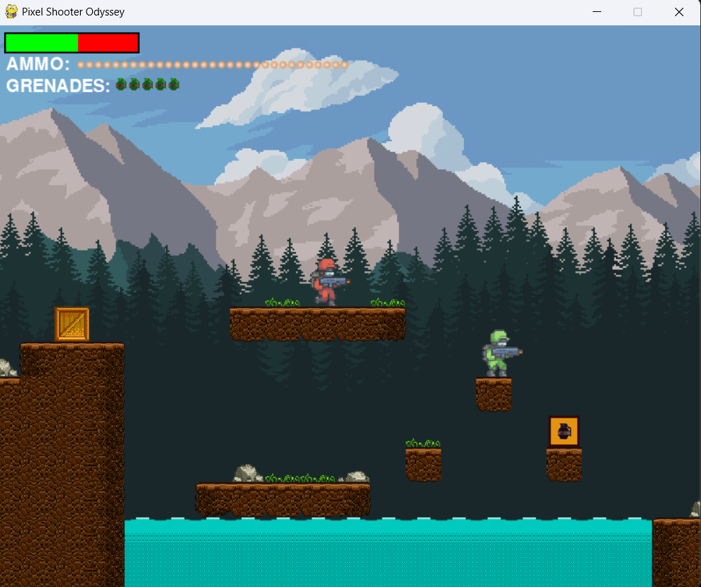

SNAPSHOTS OF GAME SCREEN

**CONCLUSION:-**

PIXEL SHOOTER ODYSSEY was developed using the Pygame library, which provides functionality for creating 2D games in Python. Pygame simplifies tasks such as handling graphics, user input, and audio, allowing developers to focus on gameplay mechanics and design.

The game's code is organized into modular components, such as player controls, enemy behavior, collision detection, and shooting. This modular structure makes the code easy to understand, maintain, and expand upon.

Future Enhancement:-

**Additional Enemy Types:** Introduce different types of enemy with unique abilities and behaviors to add variety to the gameplay.

**Boss Battles:** Implement challenging boss battles at certain intervals, requiring strategic thinking and precise shooting to defeat.

**Scoring System:-**Enhanced scoring system for much excitement.

**Multiplayer Mode:** Add a multiplayer mode where players can compete against each other in real-time or cooperate to fend off increasingly difficult waves of enemies.

Conclusion and Future improvements